**Exercise 3**

Question 5

***Aim:*** Write an external style sheet to format the Internet.html document as attached to apply

following effects: -  
  
                    1. Put a background color and image with gradient overlay.  
                    2. Make h1 heading 30px, bolder, use color according to your background.  
                    3. Paragraphs should have font size 15px and choose color according to background.  
                    4. Increase line spacing in paragraph text.  
                    5. Highlight important words and use styling for that.  
                    6. Make h2 heading 20px and choose color according to background.

***Code:***

**Internet.html**

<!DOCTYPE html>

<html>

  <head>

    <title>Aashita Goyal (1913541) Exercise3-Q5</title>

    <link rel="stylesheet" href="Internet.css" />

  </head>

  <body>

    <div class="heading1"><h1>&nbsp;INTERNET</h1></div>

    <br />

    <div class="para">

      <p>

        The

        <strong><u>Internet</u></strong>

        , sometimes called simply "

        <strong><u>the Net</u></strong>

        ," is a worldwide system of computer networks -- a network of networks

        in which users at any one computer can, if they have permission, get

        information from any other computer (and sometimes talk directly to

        users at other computers). It was conceived by the Advanced Research

        Projects Agency (ARPA) of the U.S. government in 1969 and was first

        known as the

        <strong><u>ARPANet</u></strong>

        . The original aim was to create a network that would allow users of a

        research computer at one university to "talk to" research computers at

        other universities. A side benefit of ARPANet's design was that, because

        messages could be routed or rerouted in more than one direction, the

        network could continue to function even if parts of it were destroyed in

        the event of a military attack or other disaster.

      </p>

      <p>

        &nbsp; &nbsp; &nbsp; &nbsp; &nbsp; &nbsp; &nbsp; Today, the Internet is

        a public, cooperative and self-sustaining facility accessible to

        hundreds of millions of people worldwide. It is used by many as the

        primary source of information consumption, and fueled the creation and

        growth of its own social ecosystem through social media and content

        sharing. Furthermore, e-commerce, or online shopping, has become one of

        the largest uses of the Internet.

      </p>

    </div>

    <br />

    <br />

    <br />

    <br />

    <br />

    <div class="heading2"><h2>&nbsp; How the Internet works</h2></div>

    <div class="para">

      <p>

        <br />

        Physically, the Internet uses a portion of the total resources of the

        currently existing public telecommunication networks. Technically, what

        distinguishes the Internet is its use of a set of protocols called

        Transmission Control Protocol/Internet Protocol (TCP/IP). Two recent

        adaptations of Internet technology, the intranet and the extranet, also

        make use of the

        <strong><u>TCP/IP</u></strong>

        protocol.

      </p>

      <p>

        &nbsp; &nbsp; &nbsp; &nbsp; &nbsp; &nbsp; &nbsp;The Internet can be seen

        as having two major components: network protocols and hardware. The

        protocols, such as the TCP/IP suite, present sets of rules that devices

        must follow in order to complete tasks. Without this common collection

        of rules, machines would not be able to communicate.

      </p>

    </div>

  </body>

</html>

**Internet.css**

* {

  margin: 0;

  padding: 0;

  box-sizing: border-box;

}

body {

  background-image: linear-gradient(

      to bottom,

      rgba(33, 159, 148, 0.52),

      rgba(232, 232, 166, 0.73)

    ),

    url('../images/img1.jpg');

  width: 80%;

  height: 400px;

  background-size: cover;

  color: white;

  padding: 20px;

}

h1 {

  font-size: 30px;

  font-style: bolder;

  font-weight: bolder;

  color: #19765d;

  font-family: 'Franklin Gothic Medium', 'Arial Narrow', Arial, sans-serif;

}

p {

  font-size: 15px;

  font-weight: 500;

  font-family: 'Lucida Sans', 'Lucida Sans Regular', 'Lucida Grande',

    'Lucida Sans Unicode', Geneva, Verdana, sans-serif;

}

h2 {

  font-size: 20px;

  /*  color: #646E21; */

  color: #e5fd46;

  font-weight: bolder;

  font-family: 'Franklin Gothic Medium', 'Arial Narrow', Arial, sans-serif;

}

strong {

  color: black;

  font-weight: 500;

}

.heading1 {

  border-style: groove;

  width: 150px;

  background-image: linear-gradient(

    to right,

    rgba(33, 159, 148, 0.52),

    rgba(232, 232, 166, 0.73)

  );

}

.heading2 {

  border-style: groove;

  box-shadow: #19765d;

  width: 220px;

}

.para {

  border-color: black;

  border-width: 10px;

}

***Output:***

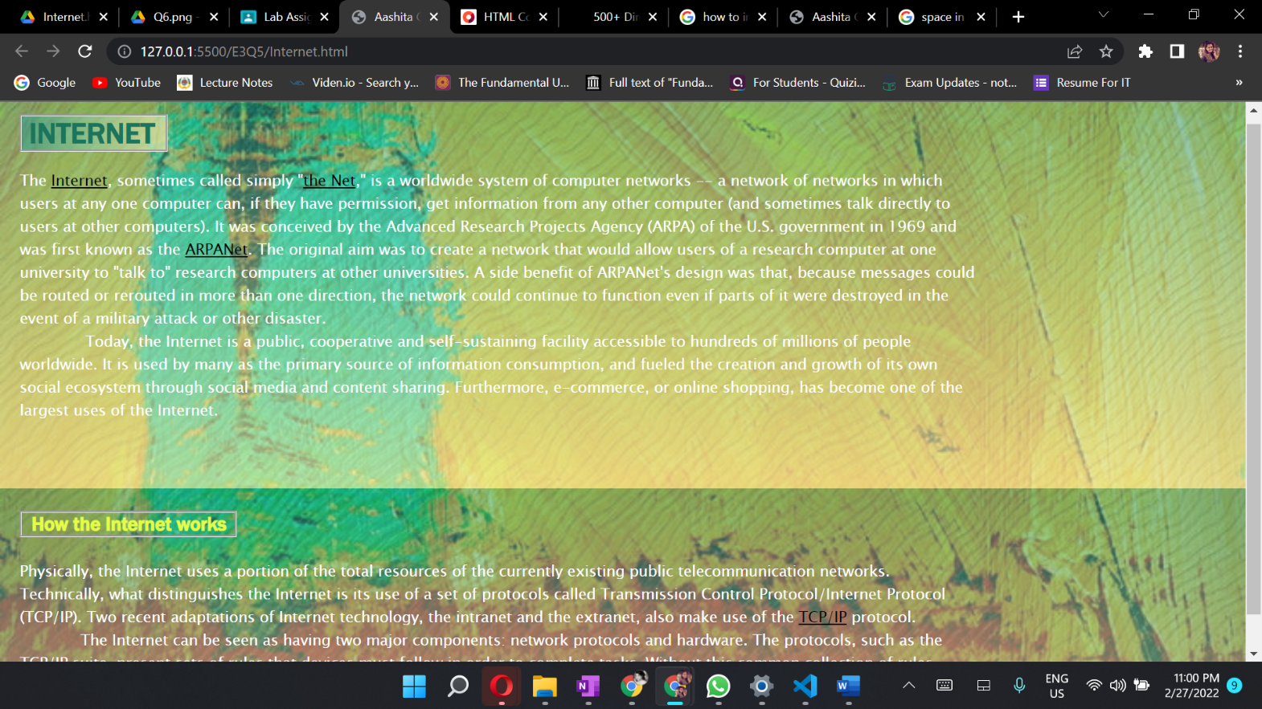

Question 6

***Aim:*** Create a webpage that displays your favorite quotations in a web page just above images.

You have to use border, height, width, margin, padding, outline properties of CSS.  
          Also use text and font properties to add effects in text to display quotations.

***Code:***

**Quotes.html**

<!DOCTYPE html>

    <html>

        <head>

            <title>Aashita Goyal (1913541) Exercise3-Q6</title>

            <link rel="stylesheet" href="Quotes.css">

        </head>

        <body>

            <section class="quote__container">

                <div><h1 class="quote__text">Quotes</h1></div>

                <div class="quote__images__container">

                    <div class="quote__images__row__one">

                        <br>

                        <div class="quote__image__1">

                            <div class="quote__1">

                                <br>

                                <div class="quote__first">

                                    <br>

                                        <p>

                                            Your last choice <br>

                                              is God's first.

                                        </p>

                                </div>

                            </div>

                        </div>

                        <div class="quote__image__2">

                            <div class="quote__2">

                                <div class="quote__second">

                                        <p>

                                            Success is the sum of

                                            small efforts,<br>

                                            Repeated day in and

                                            day out

                                        </p>

                                </div>

                            </div>

                        </div>

                    </div>

                    <div class="quote__images__row__two">

                        <div class="quote__image__3">

                            <br><br>

                            <div class="quote__3">

                                <div class="quote__third">

                                        <p>

                                            Whether you think you <br>

                                            can, or think you can't <br>

                                            you are always right

                                        </p>

                                </div>

                            </div>

                        </div>

                        <div class="quote__image__4">

                            <div class="quote__4">

                                <div class="quote__fourth">

                                        <p>

                                            The only constant <br>

                                            is change

                                        </p>

                                </div>

                            </div>

                        </div>

                    </div>

                </div>

            </section>

            <br><br><br>

        </body>

    </html>

**Quotes.css**

body{

    background-image:

    linear-gradient(to right,  rgba(34, 34, 53, 0), rgba(220, 202, 45, 0.92)),

    url('../images/bgs/black_paper.png');

}

.quote__container{

    width: 100%;

    padding: 50px 0;

    display: flex;

}

.quote__text{

    padding: 12px 0;

    font-family: 'Source Sans Pro', sans-serif;

    font-size: 53px;

    padding-left: 40px;

}

.quote__images__container{

    width: 65%;

    padding-left: 300px;

}

.quote__images__row__one,

.quote__images__row__two{

    width: 100%;

    display: flex;

    gap: 3px;

}

.quote__images__row__one{

    align-items: baseline;

    margin-bottom: 3px;

}

    .quote__image__1,

    .quote__image__4{

        width: 150%;

        height: 190px;

    }

    .quote__image__2,

    .quote__image__3{

        width: 170%;

        height: 230px;

    }

    .quote__1,

    .quote__2,

    .quote__3,

    .quote__4{

        width: 100%;

        height: 100%;

    }

    .quote__1{

        background-image: url('../images/img9.jpg');

        border-radius: 10px;

        border-style: double;

        border-width: 10px;

       /* position: absolute;

        height: 180px;

        width: 377px;

        top: 30;

        bottom: 40;*/

    }

    .quote__2{

        background-image: url('../images/img10.jpg');

        padding-bottom: 0;

        border-radius: 10px;

        border-style: double;

        border-width: 10px;

        margin-left: 20px;

    }

    .quote__3{

        background-image: url('../images/img22.jpg');

        border-radius: 10px;

        border-style: double;

        border-width: 10px;

    }

    .quote__4{

        background-image: url('../images/img30.jpg');

        border-radius: 10px;

        border-style: double;

        border-width: 10px;

        margin-left: 20px;

    }

    .quote__first{

        color: white;

        padding-top: 30px;

        padding-left: 50px;

    }

    .quote__second{

        color: white;

        padding-left: 130px;

        padding-top: 70px;

    }

    .quote__third{

        color: white;

        padding-top: 25px;

        padding-left: 245px;

    }

    .quote__fourth{

        color: white;

        padding-top: 30px;

        padding-left: 70px;

    }

***Output:***

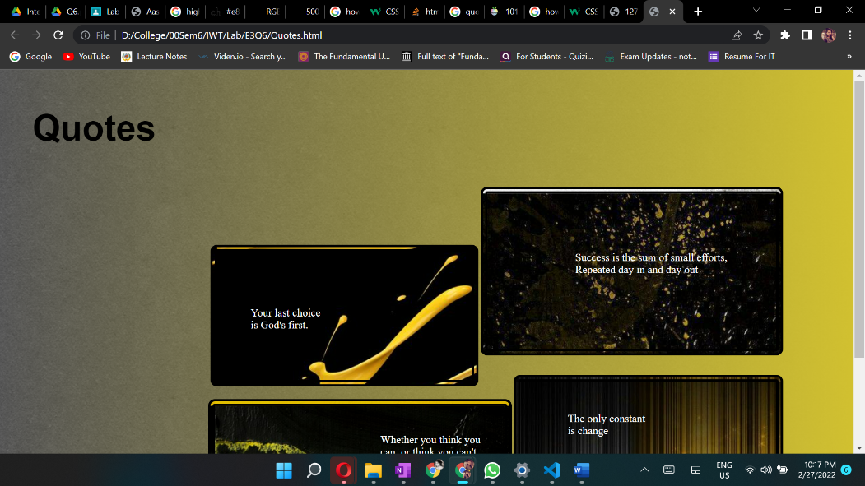

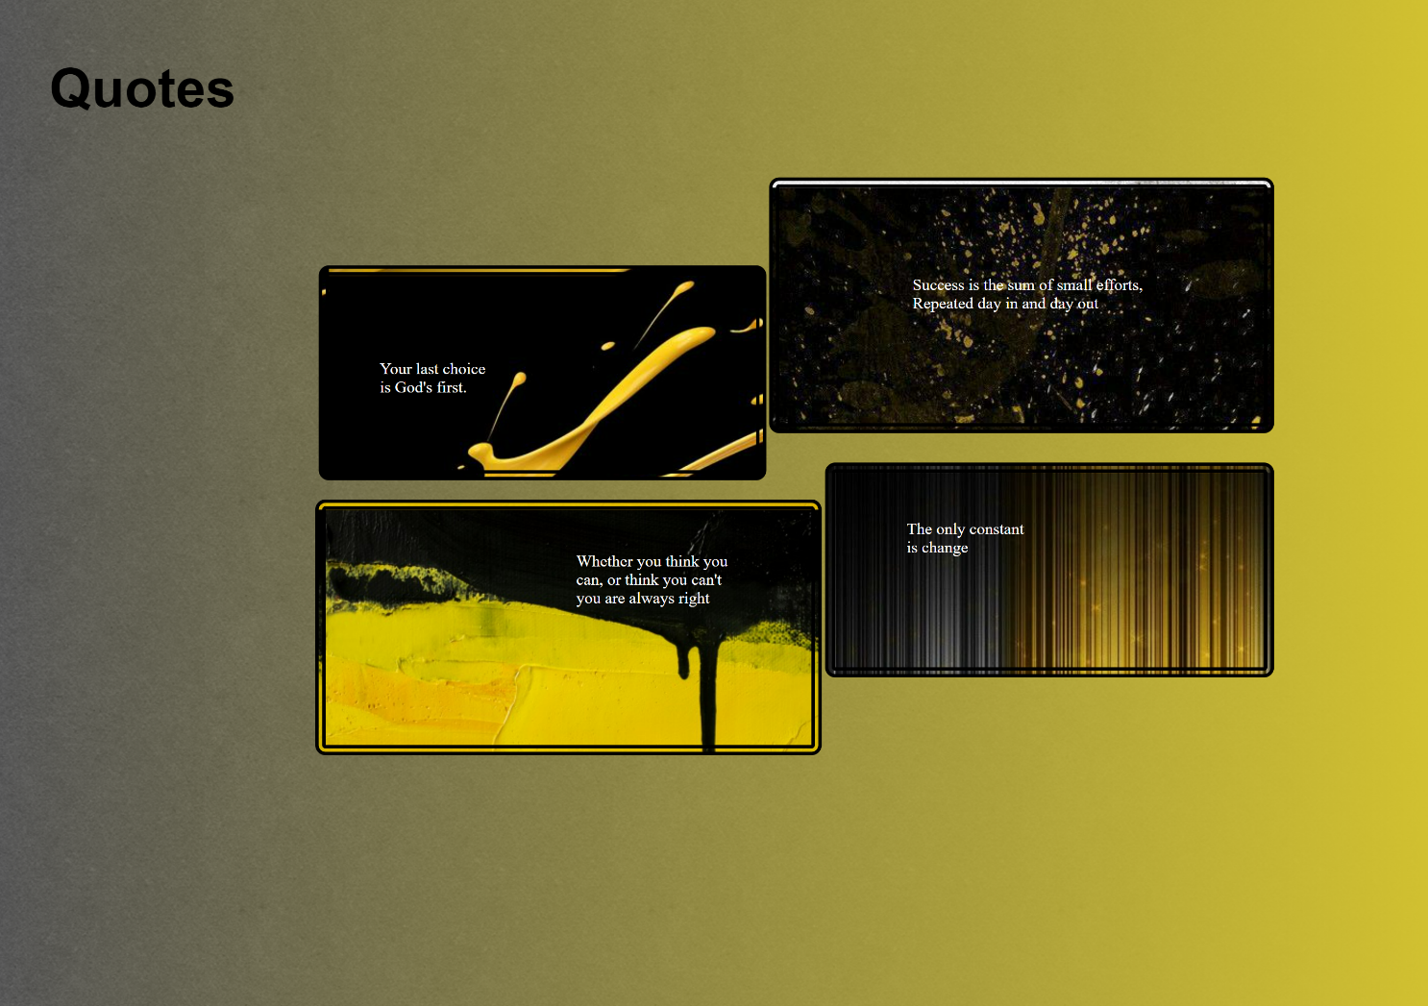***Full Page Screenshot:***